**Tax Exemption Information:**

Federal employees can use the following three types of U.S. General Services Administration (GSA) SmartPay 3 cards to purchase lodging and travel related expenses without paying retail sales or lodging tax:

* Travel cards (blue) are exempt if the sixth digit from the left is a 6,7,8,9, or 0 (zero).
* Tax advantage travel cards (grey) are exempt if the sixth digit from the left is a 5.
* Integrated cards (gold) are always exempt no matter what the number sequence.
* The red card is used to procure, order, and pay for supplies and services. Therefore, the red card cannot be used to purchase lodging or travel related expenses.

Example:

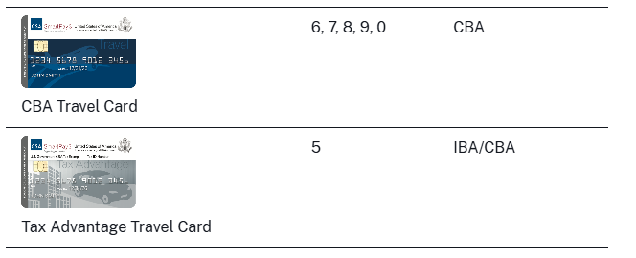

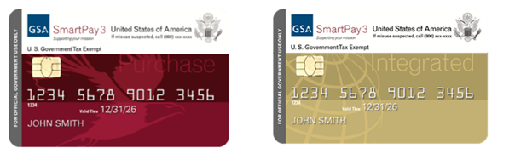

For more information, please see [US government sales | Washington Department of Revenue](https://dor.wa.gov/education/industry-guides/lodging-guide/us-government-sales#:~:text=Sales%20made%20directly%20to%20the,reimbursement%20from%20the%20federal%20government.). For more information on the GSA program, visit [https://smartpay.gsa.gov](https://smartpay.gsa.gov/).